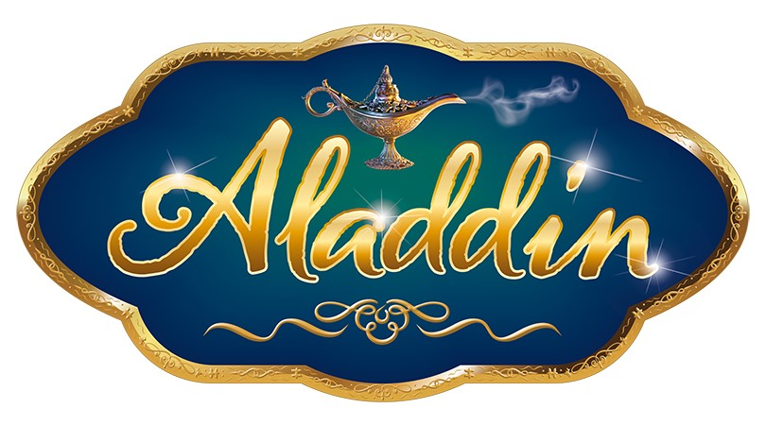

05 August 2021
ALADDIN JUVENILE AUDITIONS
SEPTEMBER 12TH 2021 - AT THE PARK BARN HORSHAM RH12 1RJ

Dear Parent/Guardian,

Please take a moment to look through this paperwork relating to juvenile auditions for this year’s pantomime, Aladdin.

Aladdin is a wonderful story and we are planning to make it the most exciting pantomime yet, especially after missing out on Panto last year. We are assembling an amazing professional cast and this will be an opportunity to work alongside them in one of the most exciting Pantomimes. We are as ever looking for strong all round performers.

Listed below is the breakdown of roles available.

There will be audition sessions starting at 10am. If you have been offered an audition, you will sent an invite with a specified time slot. Please do not turn up if you have not been offered an audition, we cannot commit to auditioning every applicant.

Auditions: Young people (age 9-16) will be taught a short dance routine by the choreographer.

The audition is designed to test your child’s strengths and will give them a taste of what it is like to audition in the industry – it will be a great opportunity for confident dancers to show off their skills. Participation in the pantomime is a huge commitment but also a wonderful experience for your child, building confidence, learning new skills and for personal development.

Please note we will be asking parents and guardians of ALL children taking part in the pantomime to share equally (alongside our professional chaperone) the task of chaperoning children backstage at shows and in rehearsals. This is something for you to consider when putting your child forward to take part in the production. In addition, if your child is successful, they MUST be available for all rehearsals and performances for which they are called.

To register your child for an audition, please complete the attached forms and return to us by Thursday 26th August 2021. We are unable to accept applications after this date.
Best wishes,
The Capitol

Attach photo here

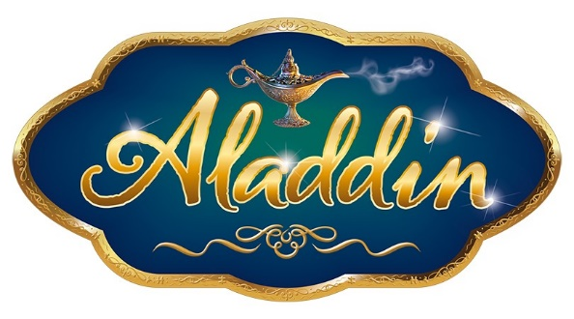

AUDITION APPLICATION FORM
SUNDAY 12TH SEPTEMBER 2021 AT THE PARK BARN (opposite The Capitol)

Young People (Aged 9-16)

SHOW DATES: FRIDAY 3 DEC 2021 – FRIDAY 31 DEC 2021
(No shows: Mon 6th Dec, Thurs 9th Dec, Mon 2th Dec, Wed 15th Dec & Sat 25th Dec.)

2 teams of children will cover alternate performances across the show dates (approx. 22 shows each).
Any child submitted must be available for ALL rehearsals;

Rehearsals:

Saturday 13th November – ALL DAY
Sunday 14th November – ALL DAY
Tuesday 16th November – 16:45 – 20:00
Thursday 18th November – 16:45 – 20:00
Friday 19th November - 16:45 – 20:00
Saturday 20th November – ALL DAY
Tuesday 23rd November - 16:45 – 20:00
Thursday 25th November - 16:45 – 20:00
Friday 26th November - 16:45 – 20:00
Monday 29th December – ALL DAY
Tuesday 30th December – ALL DAY
Wednesday 1st December – ALL DAY
Thursday 2nd December – ALL DAY

Applicant’s Details:
Name:
Address:
Postcode:
Telephone Number:
Email:
School/College:
Dance/Theatre Club:
Date of Birth: Age at start of show:
Height (feet & inches):

Please tick box to indicate recent previous experience:
- Capitol Panto 2017 Jack & The Beanstalk

- Capitol Panto 2018 Sleeping Beauty

- Capitol Panto 2019 Peter Pan

- Other (please specify)…

Parent/Guardian Details:
Name: Relation:
Mobile Tel: Email:
Licensed Chaperone? Yes / No

Please fill in the audition form and return with a passport size photograph by
Thursday 26th August 2021 to:
Pantomime Casting, The Capitol, North Street, Horsham, RH12 1RG

PANTOMIME JUVENILE CAST (Licencing Age)

Data Protection Act 2017/8

Personal Data will be held in accordance with the Data Protection Act 2017/8 and will not be shared with any third parties, other than the Child Employment and Entertainment Team at West Sussex County Council (WSCC). A copy of our privacy policy can be found at www.thecapitolhorsham.com

Sharing data with WSCC is a compulsory requirement as part of our performance licence application. It is essential, in order for your child to be able to participate in this production. Items of data we will share as part of the licence application include (but are not limited to): Name, Date of Birth, Address, Photograph, Health Declaration and Current School. For more information on how West Sussex County Council use this information as part of the licence application, please visit their website: https://www.westsussex.gov.uk/privacy-policy/.

Where necessary, Health Declarations will be shared with the relevant staff members (e.g. production team, venue staff and chaperones) in order to ensure the wellbeing of your child.

Data pertaining to children will only be retained for the relevant period as deemed necessary by the Children in Entertainment Team at West Sussex County Council. In most cases, personal data will be deleted after the production comes to an end. Participants can request it to be erased at any point, provided it isn’t a legal requirement that we retain it.

If you would like to remain on our mailing list to hear more about our student offers and auditions or performance opportunities, please tick here to opt in to receive emails

